Assigning Team to an Activity

*Overview:*

Assigning personnel to an activity is a process performed by an activity supervisor and involves allocation of human resources to achieve best result in efficient and effective manner.

Whereas workers may be trained to perform more than one type of activities and possess adequate experience and certification, this process requires time and a need to be optimized.

Under existing design, procedure of assigning is the one- by one is very tedious and inefficient.

To optimize this time costly procedure TEAM entity is introduced.

***Team*** is a group of registered personnel that possess relevant experience and proven to work best together.

Implementation of Team entity is done through Team table.

Example:

Team Table:

|  |  |
| --- | --- |
| Team Id | PK |
| Team Name | Text |
| Team Size | Small Int. |
| Note: | Text |

|  |  |  |  |
| --- | --- | --- | --- |
| Team Id | Team Name | Team Size | Activity /Note |
| 001 | Harvest Small | 15 | Ongoing Harvest |
| 002 | Harvest Large | 30 | Main / Mid Harvest |
| 003 | Weeding |  | Corona Weeding |
| 004 | Pruning | 2 | Seal the cuts |

***Team Members table is an associative table (many -to- many) that hold relation between different teams and workers. Any worker may belong to more than one team. It is up to Field Manager to manage teams***

*Building Teams:*

Team Members Associative Table

|  |  |
| --- | --- |
| Team Members | |
| Team Id | FK |
| HR_Id | Fk |
| Lead | Boolean |
| Statistician | Boolean |

Any HR can be added to as many teams as possible.

To manage Teams user should access Teams Menu item through Human Resources Tab

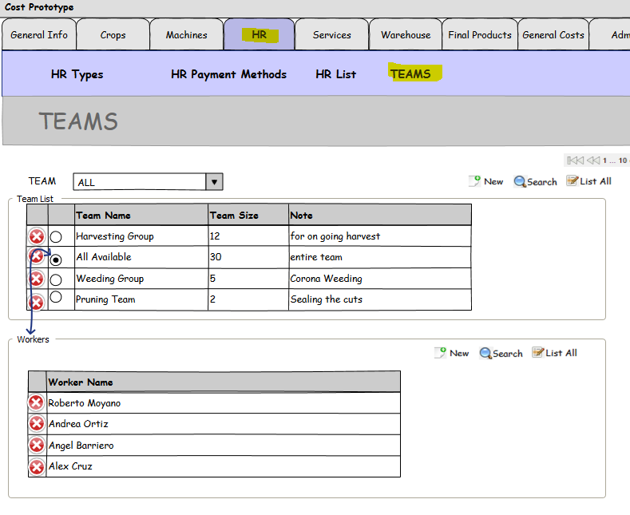

***1. User can see list of previously assigned workers by selecting radio button next to Team Name.***

***2. User can delete worker from the list***

***3. User can add one or more workers to the team***

***4. Any time workers are removed or added to the team; system calculates and updates total team***

***size (number of workers on the team )***

***5***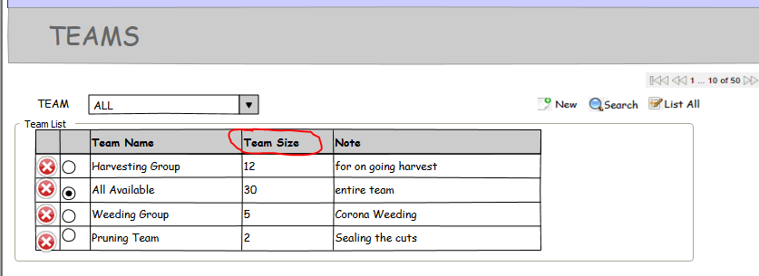

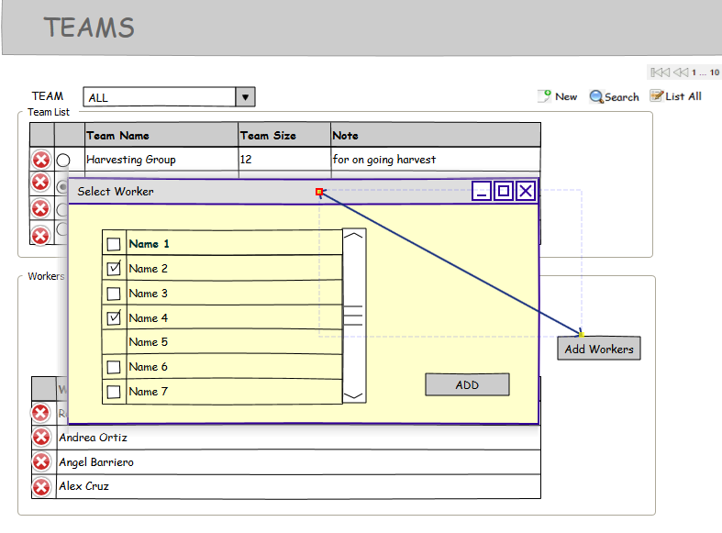

*Assigning Teams:*

|  |  |
| --- | --- |
| Team to Activity | |
| Team Id | FK |
| Activity_Id | Fk |

***During process of assignment System should verify that*** each ***member of the team is available to perform an activity to which he is being assigned.***  As a result system returns number of assigned people and Number and the List of the people that were not assigned with a reason (vacation, assigned to another activity, etc...)

1. If system finds a worker in a vacation list (TBD), it reports “on vacation”
2. If system find a worker already assigned to another activity, it reports “assigned to “***Activity name*** on date (DD/MM/ YYYY) the date to come from Activity Date. “. “Activity Name” is to come from Activity Name ID.

There process of assigning Personnel to an activity should follow same business logic implemented for single worker assignment process.

\**Existing process of personnel assignment validates certificates, age requirements and materninty/breasfeeding for dangerous activities.*

